- Open Google and Type MYSQL -- click first site
- Go to download section
- Find and click - MySQL Community Edition
- Click - MySQL Installer for Windows
- Click second Download option - Windows (x86, 32-bit), MSI Installer
- It will asking login or sign up don’t login and sign up look below
- No thanks, just start my download.
- After download, double click and follow below steps

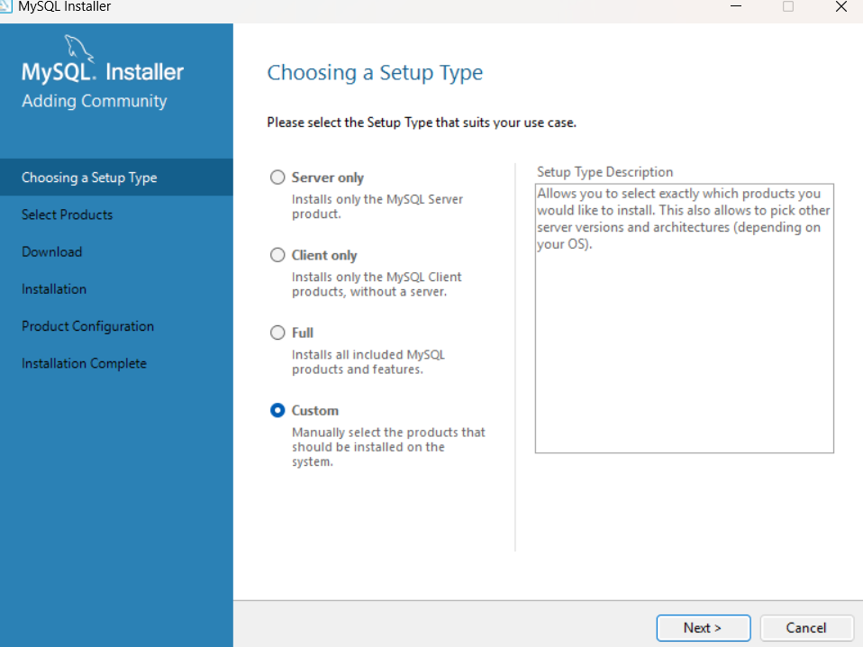
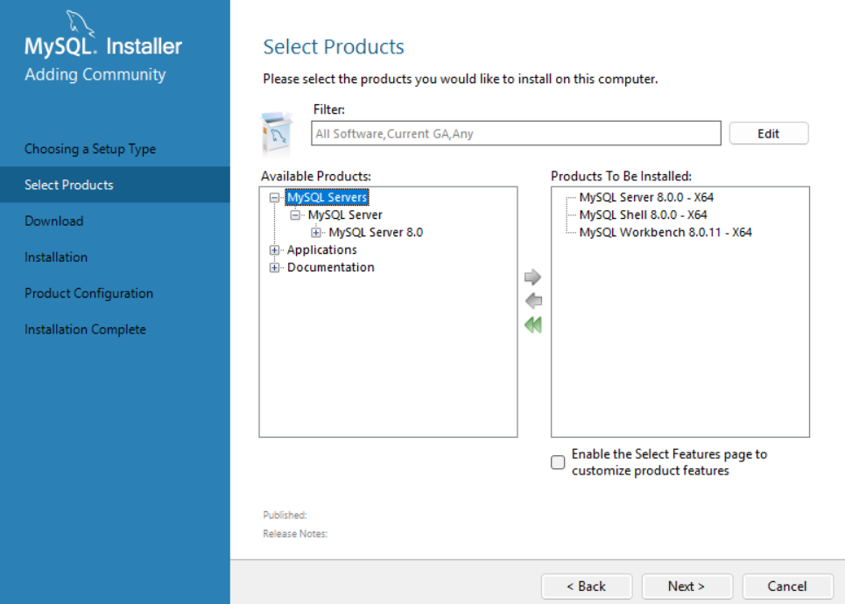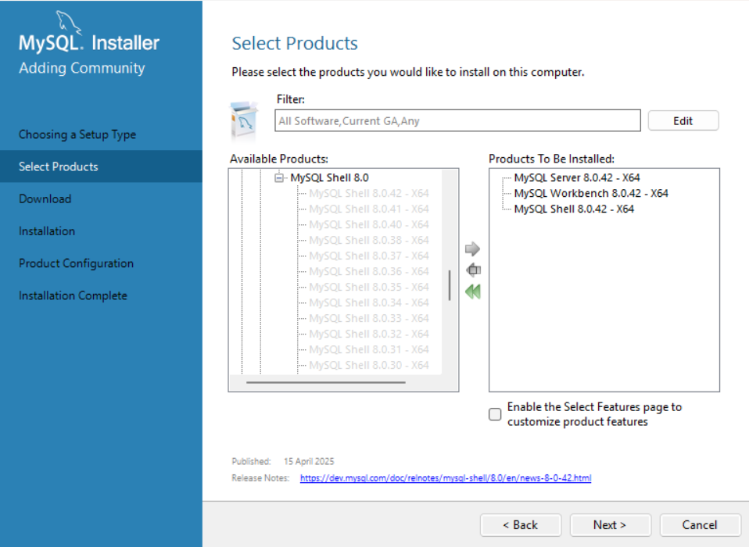
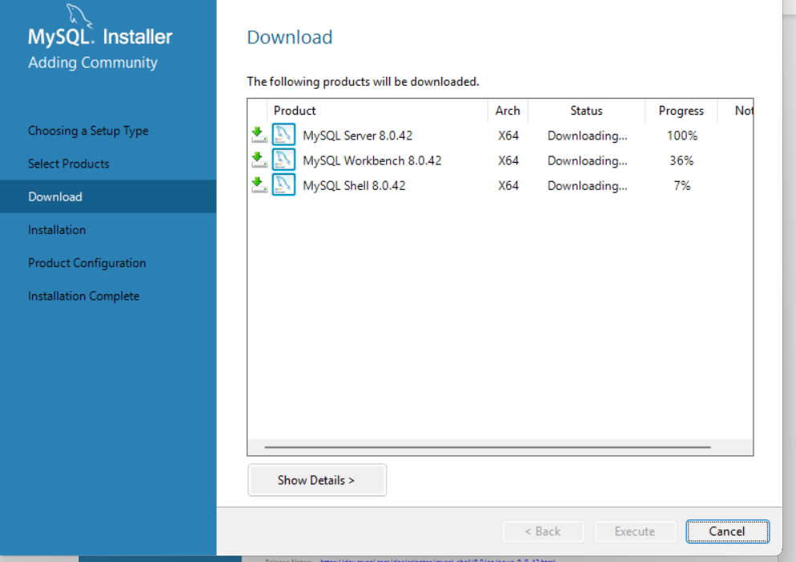
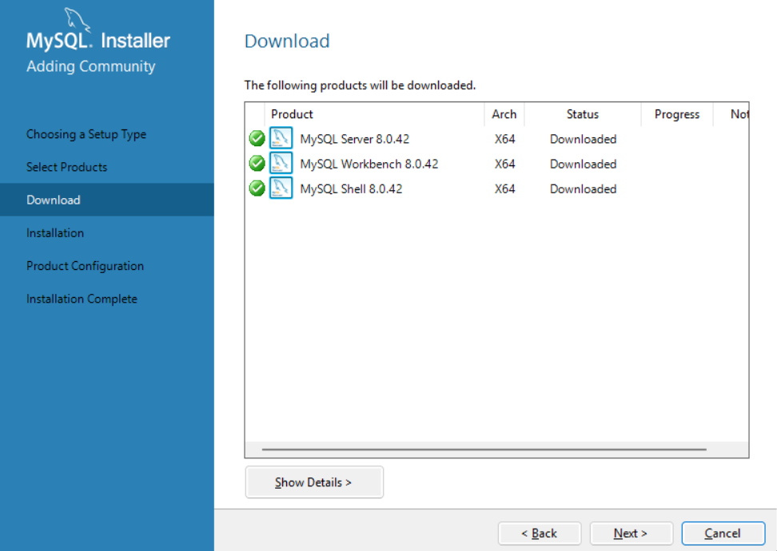
After download and next step is installation steps
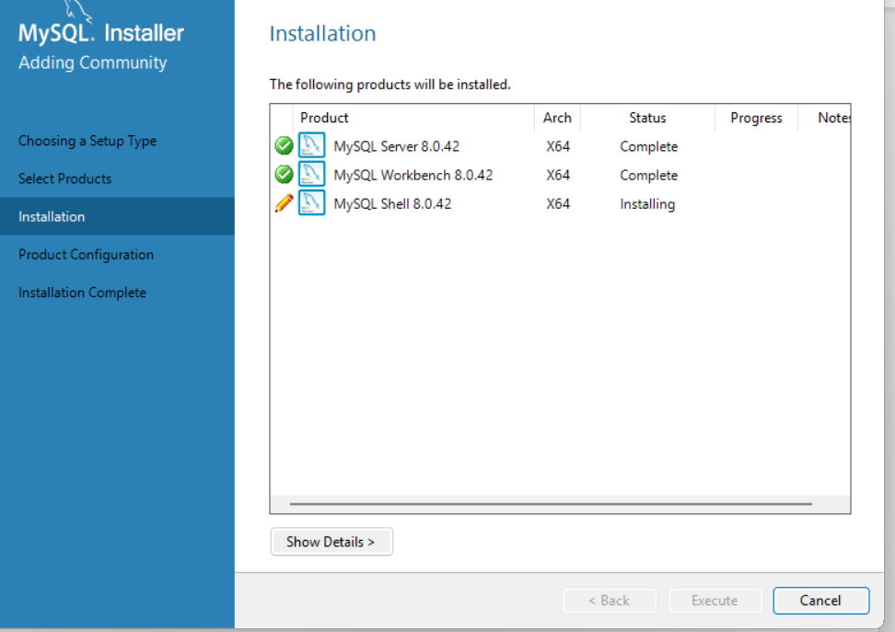
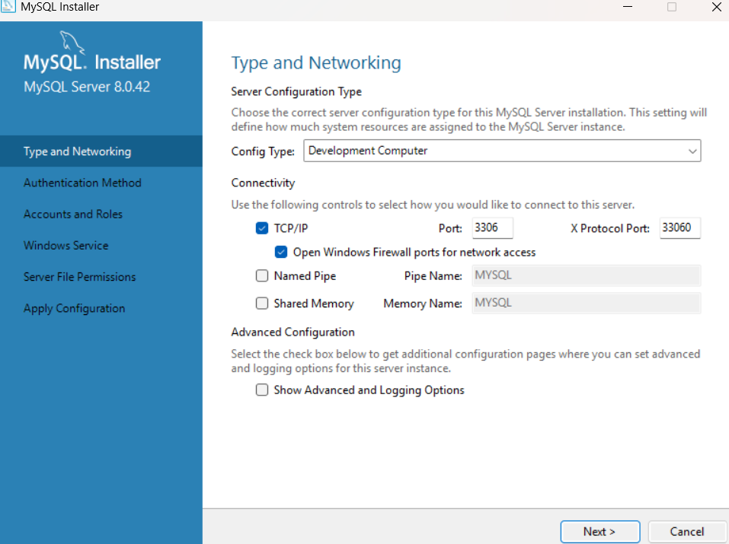
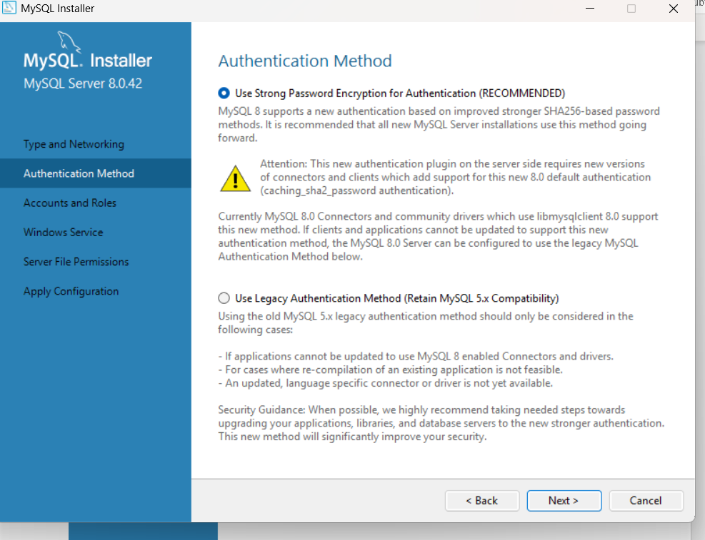
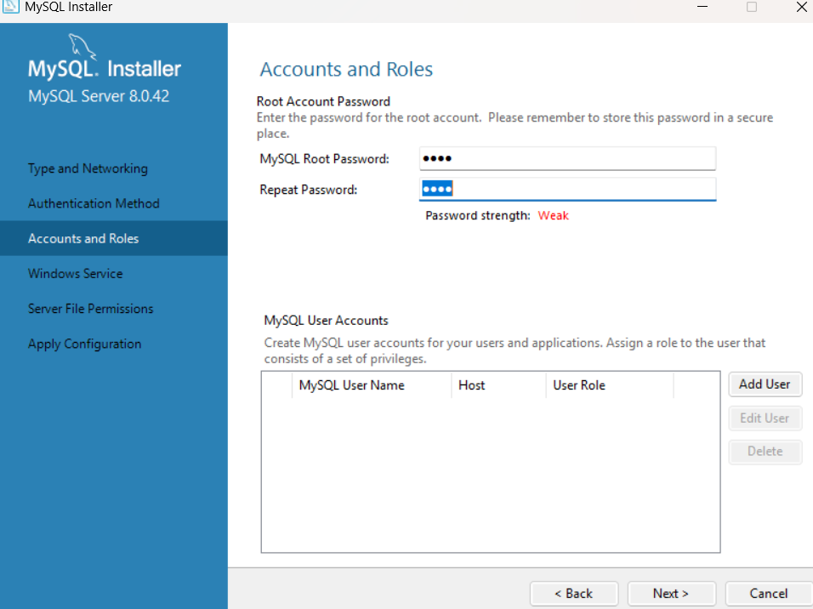
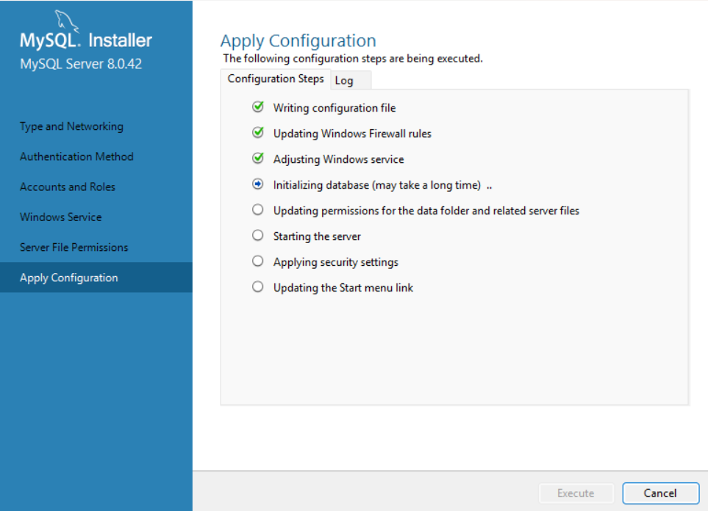
Finallymysql server successfully completed

Enter password: ***********
Welcome to the MySQL monitor. Commands end with ; or \g.
Your MySQL connection id is 14
Server version: 8.0.43 MySQL Community Server - GPL

Copyright (c) 2000, 2025, Oracle and/or its affiliates.

Oracle is a registered trademark of Oracle Corporation and/or its
affiliates. Other names may be trademarks of their respective
owners.

Type 'help;' or '\h' for help. Type '\c' to clear the current input statement.

mysql> show database
-> show databases
-> show databases;
ERROR 1064 (42000): You have an error in your SQL syntax; check the manual that corresponds to your MySQL server version for the right syntax to use near 'database
show databases
show databases' at line 1
mysql> show databases;
+--------------------+
| Database |
+--------------------+
| classicmodels |
| information_schema |
| mysql |
| mysql_python |
| mysql_python1 |
| performance_schema |
| sql_intro |
| sql_iq |
| sql_joins |
| sys |
| triggers |
+--------------------+
11 rows in set (0.03 sec)

mysql> create database nit;
Query OK, 1 row affected (0.05 sec)

mysql> show databases;
+--------------------+
| Database |
+--------------------+
| classicmodels |
| information_schema |
| mysql |
| mysql_python |
| mysql_python1 |
| nit |
| performance_schema |
| sql_intro |
| sql_iq |
| sql_joins |
| sys |
| triggers |
+--------------------+
12 rows in set (0.00 sec)

mysql> use nit;
Database changed
mysql> create table student(name varchar(30), id int not null primary key, address varchar(50),marks int);
Query OK, 0 rows affected (0.09 sec)

mysql> desc student;
+---------+-------------+------+-----+---------+-------+
| Field | Type | Null | Key | Default | Extra |
+---------+-------------+------+-----+---------+-------+
| name | varchar(30) | YES | | NULL | |
| id | int | NO | PRI | NULL | |
| address | varchar(50) | YES | | NULL | |
| marks | int | YES | | NULL | |
+---------+-------------+------+-----+---------+-------+
4 rows in set (0.03 sec)

mysql> insert into student(marks,id,name,address,)values(78,12,'prakash','hyd');
ERROR 1064 (42000): You have an error in your SQL syntax; check the manual that corresponds to your MySQL server version for the right syntax to use near ')values(78,12,'prakash','hyd')' at line 1
mysql> insert into student(marks,id,name,address)values(78,12,'prakash','hyd');
Query OK, 1 row affected (0.04 sec)

mysql> insert into student values('kodi',40,'bng',66);
Query OK, 1 row affected (0.03 sec)

mysql> insert into student values('alex',45,'hyd',79),('cathy',17,'delhi',90),('dolly',48,'pune',67),('chancy',78,'mumbai'34);
ERROR 1064 (42000): You have an error in your SQL syntax; check the manual that corresponds to your MySQL server version for the right syntax to use near '34)' at line 1
mysql> insert into student values('alex',45,'hyd',79),('cathy',17,'delhi',90),('dolly',48,'pune',67),('chancy',78,'mumbai'34);
ERROR 1064 (42000): You have an error in your SQL syntax; check the manual that corresponds to your MySQL server version for the right syntax to use near '34)' at line 1
mysql> insert into student values ('alex',45,'hyd',79),('cathy',17,'delhi',90),('dolly',48,'pune',67),('chancy',78,'mumbai'34);
ERROR 1064 (42000): You have an error in your SQL syntax; check the manual that corresponds to your MySQL server version for the right syntax to use near '34)' at line 1
mysql> insert into student values ('alex',45,'hyd',79),('cathy',17,'delhi',90),('dolly',48,'pune',67),('chancy',78,'mumbai',34);
Query OK, 4 rows affected (0.03 sec)
Records: 4 Duplicates: 0 Warnings: 0

mysql> select *from student
-> select * from student
-> select * from student;
ERROR 1064 (42000): You have an error in your SQL syntax; check the manual that corresponds to your MySQL server version for the right syntax to use near 'select * from student
select * from student' at line 2
mysql> select * from student;
+---------+----+---------+-------+
| name | id | address | marks |
+---------+----+---------+-------+
| prakash | 12 | hyd | 78 |
| cathy | 17 | delhi | 90 |
| kodi | 40 | bng | 66 |
| alex | 45 | hyd | 79 |
| dolly | 48 | pune | 67 |
| chancy | 78 | mumbai | 34 |
+---------+----+---------+-------+
6 rows in set (0.00 sec)

mysql> select name * from student;
ERROR 1064 (42000): You have an error in your SQL syntax; check the manual that corresponds to your MySQL server version for the right syntax to use near 'from student' at line 1
mysql> select name from student;
+---------+
| name |
+---------+
| prakash |
| cathy |
| kodi |
| alex |
| dolly |
| chancy |
+---------+
6 rows in set (0.00 sec)

mysql> select name from student,id;
ERROR 1146 (42S02): Table 'nit.id' doesn't exist
mysql> select name,id from student;
+---------+----+
| name | id |
+---------+----+
| prakash | 12 |
| cathy | 17 |
| kodi | 40 |
| alex | 45 |
| dolly | 48 |
| chancy | 78 |
+---------+----+
6 rows in set (0.00 sec)

mysql> select name,id,marks from student;
+---------+----+-------+
| name | id | marks |
+---------+----+-------+
| prakash | 12 | 78 |
| cathy | 17 | 90 |
| kodi | 40 | 66 |
| alex | 45 | 79 |
| dolly | 48 | 67 |
| chancy | 78 | 34 |
+---------+----+-------+
6 rows in set (0.00 sec)

mysql> select * from student where id = 12;
+---------+----+---------+-------+
| name | id | address | marks |
+---------+----+---------+-------+
| prakash | 12 | hyd | 78 |
+---------+----+---------+-------+
1 row in set (0.00 sec)

mysql> insert into student values('sam',12,'hyd',56);
ERROR 1062 (23000): Duplicate entry '12' for key 'student.PRIMARY'
mysql> select name * from student;
ERROR 1064 (42000): You have an error in your SQL syntax; check the manual that corresponds to your MySQL server version for the right syntax to use near 'from student' at line 1
mysql> select * from student;
+---------+----+---------+-------+
| name | id | address | marks |
+---------+----+---------+-------+
| prakash | 12 | hyd | 78 |
| cathy | 17 | delhi | 90 |
| kodi | 40 | bng | 66 |
| alex | 45 | hyd | 79 |
| dolly | 48 | pune | 67 |
| chancy | 78 | mumbai | 34 |
+---------+----+---------+-------+
6 rows in set (0.00 sec)

mysql> update student set address='chennai' where id = 45;
Query OK, 1 row affected (0.03 sec)
Rows matched: 1 Changed: 1 Warnings: 0

mysql> select * from student;
+---------+----+---------+-------+
| name | id | address | marks |
+---------+----+---------+-------+
| prakash | 12 | hyd | 78 |
| cathy | 17 | delhi | 90 |
| kodi | 40 | bng | 66 |
| alex | 45 | chennai | 79 |
| dolly | 48 | pune | 67 |
| chancy | 78 | mumbai | 34 |
+---------+----+---------+-------+
6 rows in set (0.00 sec)

mysql> alter table student add phoneNo int;
Query OK, 0 rows affected (0.06 sec)
Records: 0 Duplicates: 0 Warnings: 0

mysql> select * from student;
+---------+----+---------+-------+---------+
| name | id | address | marks | phoneNo |
+---------+----+---------+-------+---------+
| prakash | 12 | hyd | 78 | NULL |
| cathy | 17 | delhi | 90 | NULL |
| kodi | 40 | bng | 66 | NULL |
| alex | 45 | chennai | 79 | NULL |
| dolly | 48 | pune | 67 | NULL |
| chancy | 78 | mumbai | 34 | NULL |
+---------+----+---------+-------+---------+
6 rows in set (0.00 sec)

mysql> update student set phoneNo=123;
Query OK, 6 rows affected (0.03 sec)
Rows matched: 6 Changed: 6 Warnings: 0

mysql> select * from student;
+---------+----+---------+-------+---------+
| name | id | address | marks | phoneNo |
+---------+----+---------+-------+---------+
| prakash | 12 | hyd | 78 | 123 |
| cathy | 17 | delhi | 90 | 123 |
| kodi | 40 | bng | 66 | 123 |
| alex | 45 | chennai | 79 | 123 |
| dolly | 48 | pune | 67 | 123 |
| chancy | 78 | mumbai | 34 | 123 |
+---------+----+---------+-------+---------+
6 rows in set (0.00 sec)

mysql> update student set phoneNo=456 where id = 12;
Query OK, 1 row affected (0.03 sec)
Rows matched: 1 Changed: 1 Warnings: 0

mysql> select * from student;
+---------+----+---------+-------+---------+
| name | id | address | marks | phoneNo |
+---------+----+---------+-------+---------+
| prakash | 12 | hyd | 78 | 456 |
| cathy | 17 | delhi | 90 | 123 |
| kodi | 40 | bng | 66 | 123 |
| alex | 45 | chennai | 79 | 123 |
| dolly | 48 | pune | 67 | 123 |
| chancy | 78 | mumbai | 34 | 123 |
+---------+----+---------+-------+---------+
6 rows in set (0.00 sec)

mysql> desc student;
+---------+-------------+------+-----+---------+-------+
| Field | Type | Null | Key | Default | Extra |
+---------+-------------+------+-----+---------+-------+
| name | varchar(30) | YES | | NULL | |
| id | int | NO | PRI | NULL | |
| address | varchar(50) | YES | | NULL | |
| marks | int | YES | | NULL | |
| phoneNo | int | YES | | NULL | |
+---------+-------------+------+-----+---------+-------+
5 rows in set (0.00 sec)

mysql> alter student table modify column name varchar(60);
ERROR 1064 (42000): You have an error in your SQL syntax; check the manual that corresponds to your MySQL server version for the right syntax to use near 'student table modify column name varchar(60)' at line 1
mysql> alter table student modify column name varchar(60);
Query OK, 0 rows affected (0.04 sec)
Records: 0 Duplicates: 0 Warnings: 0

mysql> desc student;
+---------+-------------+------+-----+---------+-------+
| Field | Type | Null | Key | Default | Extra |
+---------+-------------+------+-----+---------+-------+
| name | varchar(60) | YES | | NULL | |
| id | int | NO | PRI | NULL | |
| address | varchar(50) | YES | | NULL | |
| marks | int | YES | | NULL | |
| phoneNo | int | YES | | NULL | |
+---------+-------------+------+-----+---------+-------+
5 rows in set (0.00 sec)

mysql> select * from student;
+---------+----+---------+-------+---------+
| name | id | address | marks | phoneNo |
+---------+----+---------+-------+---------+
| prakash | 12 | hyd | 78 | 456 |
| cathy | 17 | delhi | 90 | 123 |
| kodi | 40 | bng | 66 | 123 |
| alex | 45 | chennai | 79 | 123 |
| dolly | 48 | pune | 67 | 123 |
| chancy | 78 | mumbai | 34 | 123 |
+---------+----+---------+-------+---------+
6 rows in set (0.00 sec)

mysql> alter table student drop column phoneNo;
Query OK, 0 rows affected (0.04 sec)
Records: 0 Duplicates: 0 Warnings: 0

mysql> select * from student;
+---------+----+---------+-------+
| name | id | address | marks |
+---------+----+---------+-------+
| prakash | 12 | hyd | 78 |
| cathy | 17 | delhi | 90 |
| kodi | 40 | bng | 66 |
| alex | 45 | chennai | 79 |
| dolly | 48 | pune | 67 |
| chancy | 78 | mumbai | 34 |
+---------+----+---------+-------+
6 rows in set (0.00 sec)

mysql> select 10 + 20;
+---------+
| 10 + 20 |
+---------+
| 30 |
+---------+
1 row in set (0.02 sec)

mysql> select * from student;
+---------+----+---------+-------+
| name | id | address | marks |
+---------+----+---------+-------+
| prakash | 12 | hyd | 78 |
| cathy | 17 | delhi | 90 |
| kodi | 40 | bng | 66 |
| alex | 45 | chennai | 79 |
| dolly | 48 | pune | 67 |
| chancy | 78 | mumbai | 34 |
+---------+----+---------+-------+
6 rows in set (0.00 sec)

mysql>

